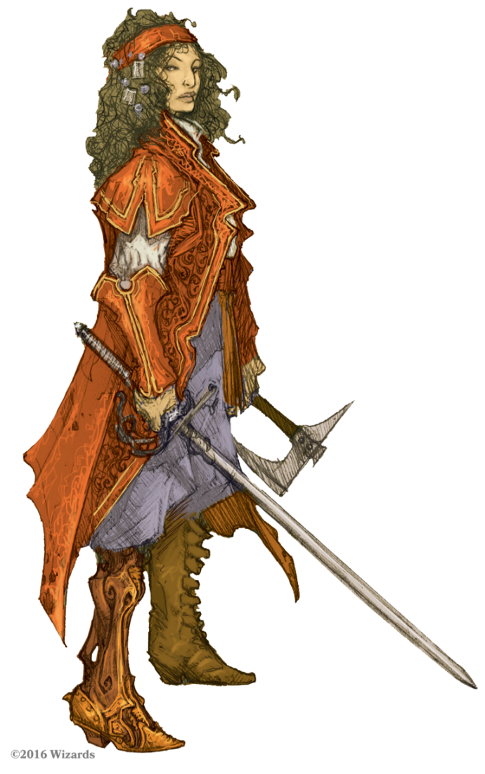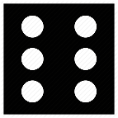

**Tinkering**

**Stealth**

**Sleight of Hand**

**Search**

**Open Doors**

**Languages**

**Architecture**

**Bushcraft**

**Climbing**

**Damage**

**HP**

**Notes**

**CHA**

**INT**

**CON**

**WI S**

**DEX**

**STR**

**AC**

**BtH**

**Paralize**

**Poison**

**Breath**

**Magic**

**Device**

**Paralize**

**Poison**

**Breath**

**Device**

**Magic**





**STR**

**DEX**

**CON**

**WI S**

**INT**

**CHA**

**Architecture**

**Bushcraft**

**Climbing**

**Languages**

**Open Doors**

**Search**

**Sleight of Hand**

**Stealth**

**Tinkering**

**HP**

**AC**

**Damage**

**BtH**

**Notes**

